Video-based fractional order identification of diffusion dynamics for the analysis of migration rates of polar and nonpolar liquids: Water and oil studies

Stefani I. E. Andrade¹, Roberto K. H. Galvão², Mario C. U. Araujo¹ and Sillas Hadjiloucas^{3}

¹ Laboratório de Automação e Instrumentação em Química Analítica e Quimiometria (LAQA) Universidade Federal da Paraíba, CCEN, Departamento de Química, Caixa Postal 5093, 58051-970, João Pessoa, PB, Brazil
² Department of Electronics Engineering, Instituto Tecnológico de Aeronáutica, São José dos Campos, SP, Brazil
³ School of Biological Sciences, Department of Biomedical Engineering, The University of Reading, Reading, RG6 6AY, UK

Abstract — Diffusion dynamics of water and oil are observed in real-time using video images. Savitzky-Golay derivative filtering ensures accurate localization of the liquid front. System identification demonstrates that a fractional-order model with only two parameters may be used to describe the dynamics of the diffusion process. The method paves the way for video-based cellulose filter paper microfluidics and lateral flow assays which are low cost and have broad diagnostic applications.

Index Terms— System identification, diffusion modeling, fractional-order model, paper-based microfluidics, lateral flow assays.

INTRODUCTION
A standard procedure for separating different chemical compounds based on their diffusion characteristics is through chromatographic and electrophoretic methods. Curve fitting procedures are often used for the determination of kinetic/affinity interaction constants and diffusion coefficients [1]. This work discusses an alternative approach using system identification. A parsimonious model of diffusion dynamics based on video-rate observations using a simple camera coupled with appropriate image processing and subsequent signal processing software is proposed. Although video-based diffusion tracking has been reported in the measurement literature [2], to our knowledge this has never been placed within a system identification framework. The proposed technique benefits from a multiplex advantage in that all the pixels across a row associated with the migration front are taken into account. Furthermore, the dynamics of the migration throughout the diffusion process across different time instances are also explicitly taken into consideration. This leads to over-determined expressions for the identified model and as a result a more accurate evaluation of the diffusion dynamics. The proposed approach provides an alternative modeling methodology to that of estimating the unknown parameters from the Stokes-Einstein equation which can be inaccurate when the signal-to-noise ratio in the migrating bands is poor [3]. Possible applications of the proposed method are discussed.

EXTRACTION OF DIFFUSION DYNAMICS USING VIDEO RECORDINGS OF THE MIGRATION FRONT
Cellulose filter paper strips (cropped for further image processing to 0.8 × 11.1 cm) Whatman Grade 1 (180 µm thickness, 11 μm pore size) and Grade 3 (390 µm thickness, 6 μm pore size) were fixed to a red-colored support. In each experiment, the support was immersed into a beaker with 35 ml of either soybean oil or distilled-deionized water. Video recordings (see figure 5 in the appendix) of the dry/wet interface motion on the paper strip were carried out using a webcam at a constant rate of 30 frames per second (fps) with a resolution of 5 pixels per millimeter. Sequentially ordered frames in RGB form (Red, Green, and Blue components at 8-bit resolution) were extracted from the video footage at a constant rate of one frame per second for further processing. The color of the support provided an enhanced background contrast to the images observed using the camera. The Image Processing ToolboxTM and the Signal Processing ToolboxTM of the MATLAB® software were employed throughout.
Figure 1a shows an image with 556 × 39 pixels acquired during the water diffusion experiment using Grade 1 filter paper. The 39 pixels in each row were co-averaged, thus reducing the image to a single column of RGB data. The blue component was selected for use in the present study. The resulting profile is displayed in Figure 1b. Each graphical unit corresponds to the size of a pixel across the vertical direction (0.2mm). As can be seen, there is a sharp increase around the vertical position at 470 graphical units, which corresponds to the dry/wet interface.

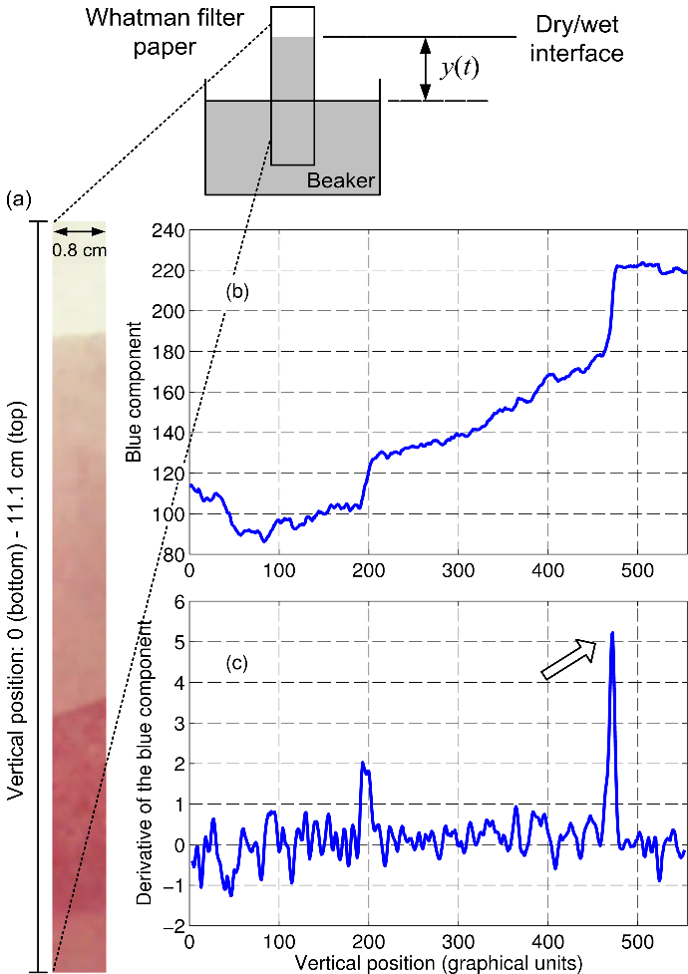

Fig. 1 (a) Image acquired during water diffusion. (b) The average value of the blue component across each row of the image. (c) 1st derivative profile. The peak indicated by an arrow was employed as a marker of the dry/wet interface position. The camera records the migration of the dry/wet interface.

A 1st-order Savitzky-Golay derivative filter [4] using a 2nd-order polynomial and a 7-point window was employed to locate the interface position more precisely. The resulting derivative profile is shown in Figure 1c. The same procedure was employed to process the oil diffusion frames (see figure 4 appendix).

The smaller peak around 200 graphical units in Figure 1c is associated with a second interface from a lighter to a darker color, closer to the bottom of Figure 1a. The darker color results from the contact of the wicked paper strip with the support. To track the main peak in the derivative profile more reliably, the search for the peak location at each frame was restricted to a window of ±100 graphical units around the peak position at the previous frame.

FRACTIONAL ORDER MODELLING OF DIFFUSION
We assume that water diffusion through the paper strip can be described by a differential equation of fractional order α as
d^{α}y(t)/dt = k u_{s}(t), where u_{s}(t) is a unit step input and k is a coefficient to be identified. Variable y(t) corresponds to the vertical position of the dry/wet interface on the paper strip concerning the surface of the liquid in the beaker, as depicted in Figure 1 (inset). The differential equation has a solution of the form

$$y(t)=\frac{k}{Γ(α)}\int{(t−τ)^{α−1}dτ=}\frac{{kt}^{α}}{αΓ(α)}$$

where Γ(α) is the Gamma function [5], which can be regarded as a generalization of the factorial (α − 1)! when α is not an integer. For
α = 0.5, this solution matches the theoretically predicted Lucas–Washburn profile [6]. However, α will also be determined as part of the identification procedure, to account for possible deviations from the theoretical response. Owing to fiber swelling and irregular distribution of the pores, it may be argued that the paper matrix does not behave as an ideal assemblage of cylindrical capillaries, as originally assumed in the theoretical analysis of the liquid flow into a porous body [7].
The values of α and k were obtained by minimizing the discrepancy between the model output and the measured values. For this purpose, the polytope algorithm [8] in MATLAB© Optimization ToolboxTM was employed.
Figure 2 presents the data acquired in the experiments of water and oil diffusion through the two types of filter paper strips. The value of zero in the vertical axis corresponds to the initial position of the dry/wet interface. The diffusion of water through the paper strip is faster compared to oil (see video files in Figure 5 in appendix), which can be ascribed to the larger viscosity and smaller polarity of the latter. Moreover, the diffusion is seen to be faster in the paper with 390 µm thickness compared to the paper with 180 µm thickness. The inset in Figure 2 presents the fitting of the data in the deionized water experiment using the 180 µm thickness Whatman paper. Similar results with excellent fit to the fractional-order model were obtained in the other experiments (see Figure 6 in appendix).

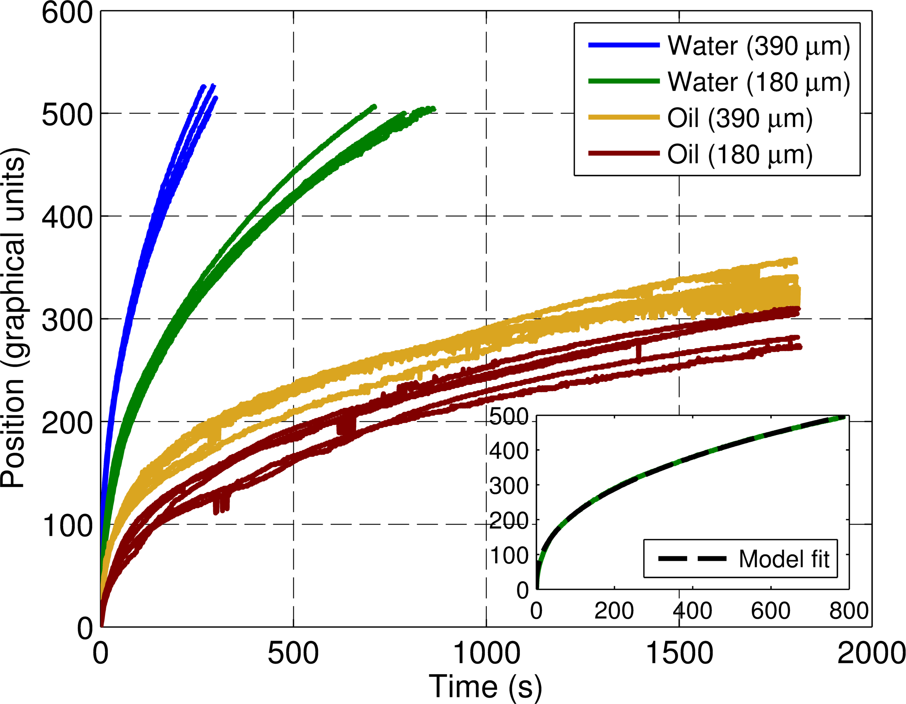

Fig. 2 Measured data using video recordings and fractional order identification results for the water diffusion experiment with 180 μm filter paper (inset).

Each experiment was carried out five times, to obtain average and standard deviation values for the identified values of α and k (as shown in Table 1 in appendix). According to t-tests performed with the MATLAB® Statistics ToolboxTM, the differences between the parameter estimates for water and oil were all significant at 95% confidence level, except for α when using the 180 μm paper. By using Hotelling's multivariate T² test [9], the differences between the pair of estimates (α, k) for water and oil were significant regardless of the paper used, with very small p-values (Table 1 Appendix).
A graphical comparison of the parameter estimates is presented in Figure 3. Classifiers can be trained to distinguish between similar flow rate samples based on the (α, k) values. As can be seen, the decision boundary obtained by using linear discriminant analysis (LDA) [10] clearly separates the water and oil samples.

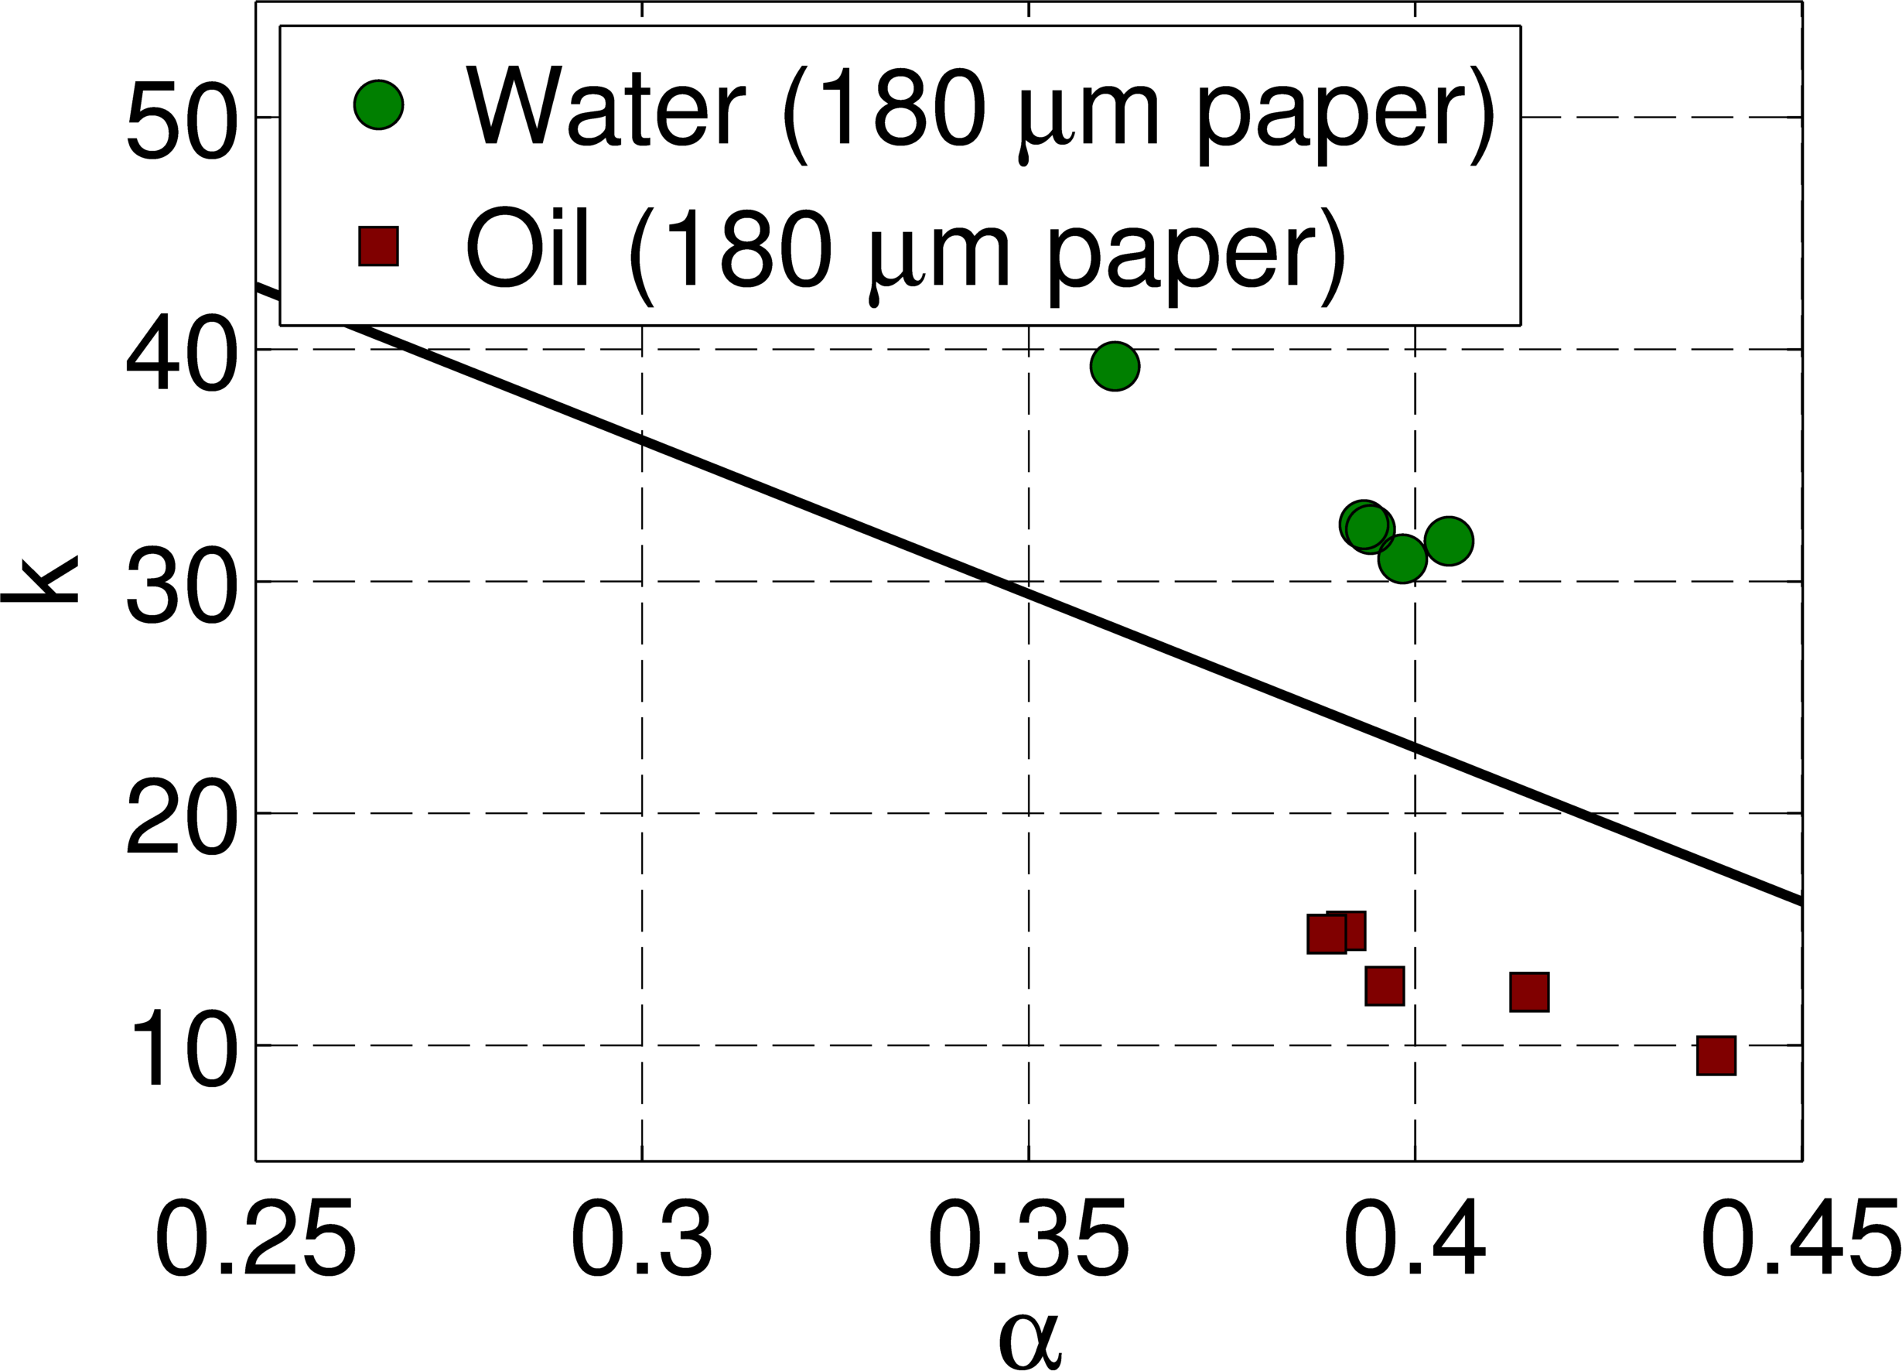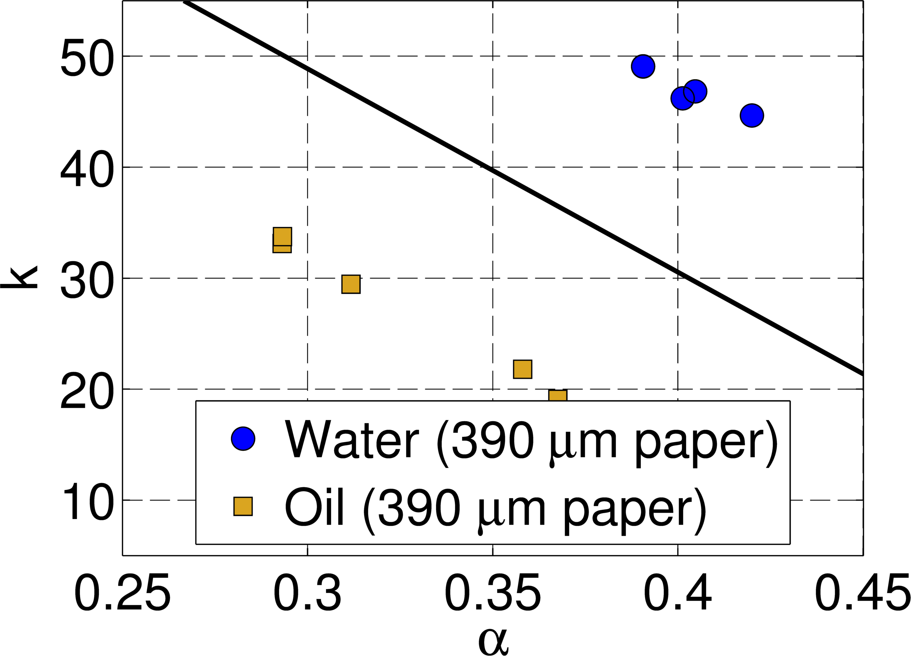

Fig. 3 Scatter plots of the identified parameters with LDA decision boundary depicted as a line.

BIOMEDICAL APPLICATIONS OF VIDEO BASED SYSTEM IDENTIFICATION
The proposed technique can be used for performance optimization of new designs of paper-based microfluidic devices with faster wicking channels [11] and provides better characterization of more complex two-dimensional and 3-dimensional diffusion architectures such as 2D and 3D microPADs, electrochemical ePADs, dissolvable bridges, and electrode-based diodes [6].
The justification for the adoption of a fractional-order model for the analysis of the diffusion process observed for polar or non-polar substances resides in the assumption that a fractal dimension may be associated with the microstructure in the paper. Similar models have also been evoked to analyze NMR measurements reflecting anomalous diffusion in experiments with Sephadex gel structures [12]. The dynamics of such processes can be well modeled using fractional-order models [13]. For more complex diffusion processes, a fractional-order model identification framework with more terms can be adopted [14].
The analysis may also be easily integrated as an add-on step in reversed-phase, normal-phase, size-exclusion, and ion-exchange chromatographic methods as well as in affinity chromatography e.g. immune-affinity chromatography for flow-based immunoassays [15] for the study of drug or hormone interactions with binding proteins. Adaptation to other clinical applications includes the automated assessment of the degree of immobilization of metal ions, molecular imprints, or aptamers, which can be used as affinity ligands for clinical analytes. Another possibility is its use in Hydrophilic-Interaction Chromatography (HILIC) to improve the separation of hydrophilic substances such as proteins, peptides, and nucleic acids [16].
Furthermore, the method may be integrated with holistic metabolite profiling approaches in liquid chromatography with mass spectrometry (MS), where there is a requirement for high sample throughput and comprehensive metabolome coverage. In this case, the limiting step is on the chromatographic side rather than the MS end [17] for both serum or plasma samples [18], so the proposed technique can potentially provide improved metabolite separation and higher resolution compared to traditional HPLC columns.
The technique may also be adapted for video-based electro-osmotic flow applications and in electrophoresis, e.g., capillary gel or capillary zone electrophoresis, in capillary isoelectric focusing (where the identified model can improve the focusing process via feedback), and for the observation of immobilized pH gradients [19] for the analysis of protein-based pharmaceuticals and quality controls. Using fractional-order control [20], it may also be possible to apply feedback to precisely manipulate the diffusion process.

AVAILABILITY OF DATA
The data that supports the findings of this study are available within the article and its supplementary material.

ACKNOWLEDGMENT
This study was financed in part by the Coordenação de Aperfeiçoamento de Pessoal de Nível Superior - Brasil (CAPES) - Finance Code 001 (PNPD grant 88882.317935/2019-01) and Conselho Nacional de Desenvolvimento Científico e Tecnológico - Brasil (CNPq) - Research Fellowships 303393/2018-1, 302349/2016-2, Grant 465768/2014-8 (INCTAA/CNPq) and Fundação de Amparo à Pesquisa do Estado de São Paulo-Brasil (FAPESP) Grant 2014/50951-4 (INCTAA).

REFERENCES
[1] Quinn J.G., ‘Evaluation of Taylor dispersion injections: Determining kinetic/affinity interaction constants and diffusion coefficients in label-free biosensing’, Anal. Biochem. 2012, 421 pp. 401–410.
[2]. Dettmer S.L., Keyser U.F., Pagliara S., ‘Local characterization of hindered Brownian motion by using digital video microscopy and 3D particle tracking’, 2014, Rev. Sci. Instrum. 85, 023708 https://doi.org/10.1063/1.4865552.
[3] Carlson B.E., Vigoreaux J.O., Maughan D.W., ‘Diffusion Coefficients of Endogenous Cytosolic Proteins from Rabbit Skinned Muscle Fibers’ Biophys. J., 2014, 106 pp 780–792.
[4] Beebe K.R., Pell R.J., Seasholtz, B., ‘Chemometrics - a practical guide’ (Wiley, New York, NY, USA, 1998).
[5] Podlubny I., Fractional differential equations. Academic Press, San Diego, 1999.
[6] Gong M.M., Sinton D., Turning the Page: Advancing Paper-Based Microfluidics for Broad Diagnostic Application, Chem. Rev. 2017, 117, 8447−8480.
[7] E. W. Washburn. The dynamics of capillary flow. Phys. Rev., 17, 273-283, 1921.
[8] Gill P.E., Murray W., Wright M.H., Practical optimization. New York: Academic Press, 1981.
[9] Trujillo-Ortiz A., (2020), HotellingT2,
(https://www.mathworks.com/matlabcentral/fileexchange/2844-hotellingt2), MATLAB Central File Exchange. Retrieved October 13, 2020.
[10] Duda, R. O., Hart, P. E. & Stork, D. G. (2001). Pattern Classification, 2nd Ed. New York: John Wiley.
[11] Camplisson C.K., Schilling K.M., Pedrotti W.L., Stone H.A. Martinez A.W., Two-ply channels for faster wicking in paper-based microfluidic devices, Lab on a Chip, DOI: 10.1039/c5lc01115a.
[12] Magin R.L., Akpa B.S., Neuberger T., Webb A.G., ‘Fractional-order analysis of Sephadex gel structures: NMR measurements reflecting anomalous diffusion’, Commun. Nonlinear Sci., 2011, 16 (12), pp 4581-4587.
[13] Jacyntho L.A., Teixeira M.C.M., Assunção E., Cardim R., Galvão R.K.H., Hadjiloucas S., ‘Identification of Fractional-Order Transfer Functions Using a Step Excitation’, Circuits Sys. -II: Express Briefs, 2015, 62, (9), pp. 896-900.
[14] Galvão R.K.H., Teixeira M.C.M., Assunção E., Paiva H.M., Hadjiloucas S., ‘Identification of fractional-order transfer functions using exponentially modulated signals with arbitrary excitation waveforms’, ISA Trans., 2020, 103, pp.10-18, https://doi.org/10.1016/j.isatra.2020.03.027.
[15] Hage D.S., ‘Affinity Chromatography: A Review of Clinical Applications’, Clinical Chemistry, 1999, 45(5) 593–615.
[16] Yoshida T., ‘Peptide separation by Hydrophilic-Interaction Chromatography: a review’, J. Biochem. Biophys. Methods, 2004, 60 pp. 265–280.
[17] Theodoridis G.A., Gika H.G, Want E.J., Wilson I.D., ‘Liquid chromatography-mass spectrometry-based global metabolite profiling: A review’, Anal. Chim. Acta, 2012, 711 pp. 7– 16.
[18] Vuckovic D., ‘Current trends and challenges in sample preparation for global metabolomics using liquid chromatography-mass spectrometry’, Anal. Bioanal. Chem., 2012, 403 pp. 1523–1548.
[19] Zhu Z, Lu J.J., Liu S., Protein separation by capillary gel electrophoresis: A review, 2012 Anal. Chim. Acta, 709 pp. 21– 31.
[20] Galvão R.K.H., Hadjiloucas S., ‘Measurement and control of emergent phenomena emulated by resistive-capacitive networks, using fractional-order internal model control and external adaptive control’, Rev. Sci. Instrum., 2019, 90, 103003.

APPENDIX

The process of extracting the diffusion profiles for oil is shown in Figure 4. Video recordings associated with the datasets of Figure 2 are shown in Figure 5. Representative plots of models fitted to the software-extracted diffusion datasets of Figure 2 are shown in Figure 6. Statistical analysis of results from 5 replicates for both water and oil diffusion using different types of filter paper are summarized in Table 1.

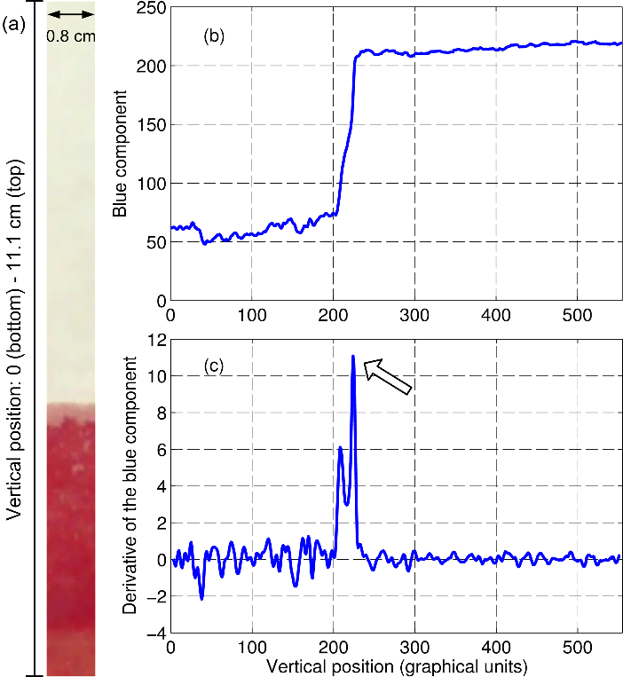

Fig. 4 (a) Image acquired during oil diffusion. (b) The average value of the blue frame component across each row of the image. (c) 1st derivative profile.

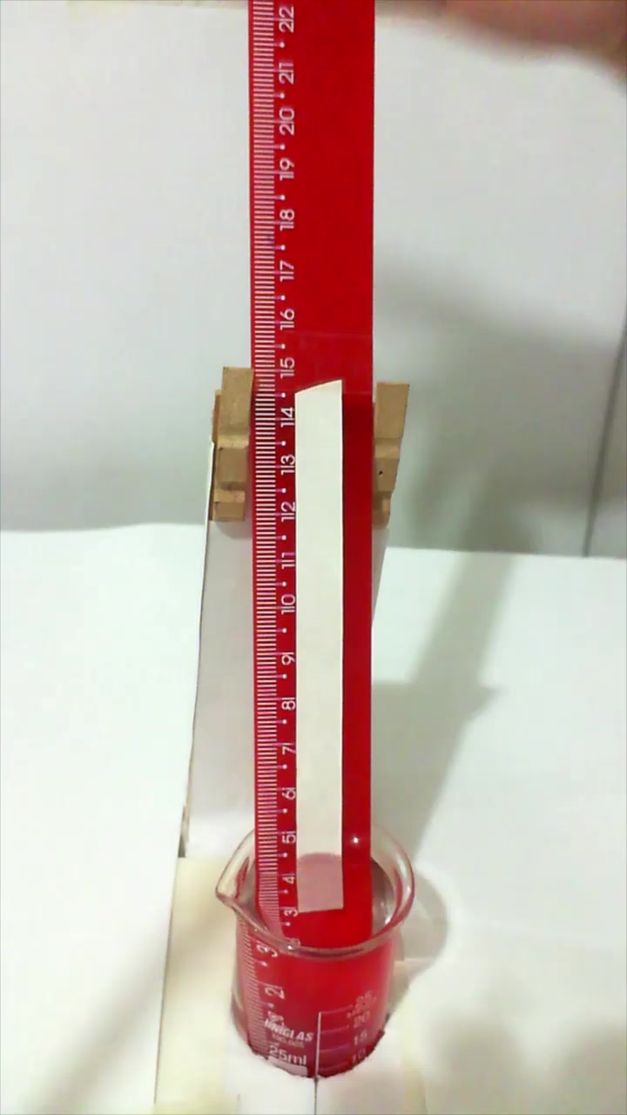

Fig. 5 Video recordings of the diffusion process observed (frames accelerated × 60 times) and subsequently extracted by the signal processing routines to generate the datasets presented in Figure 2.

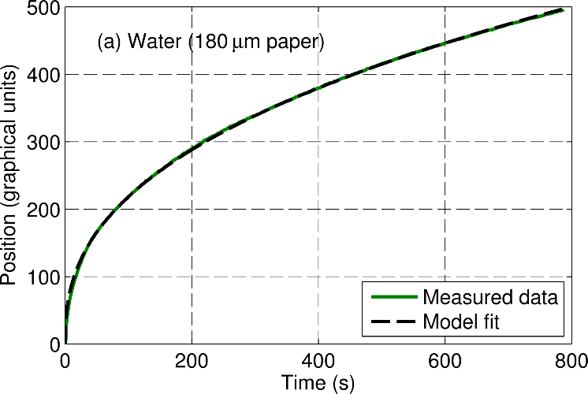
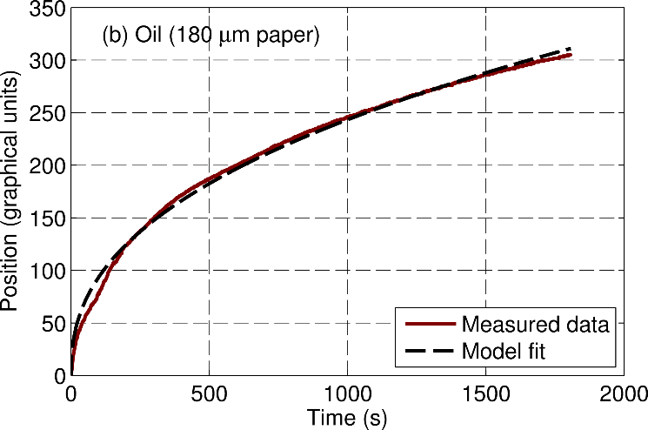
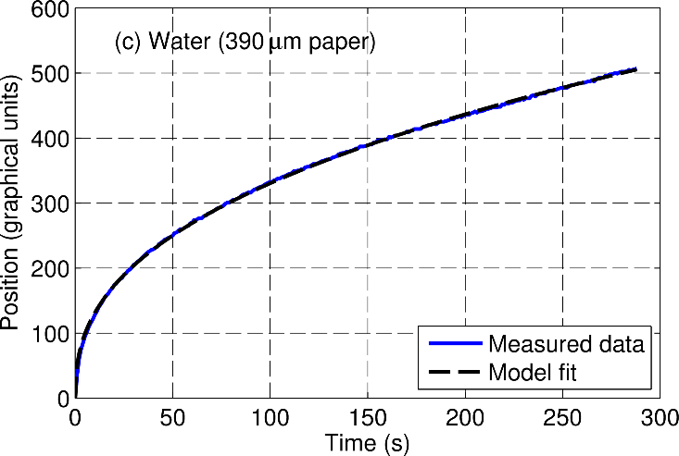
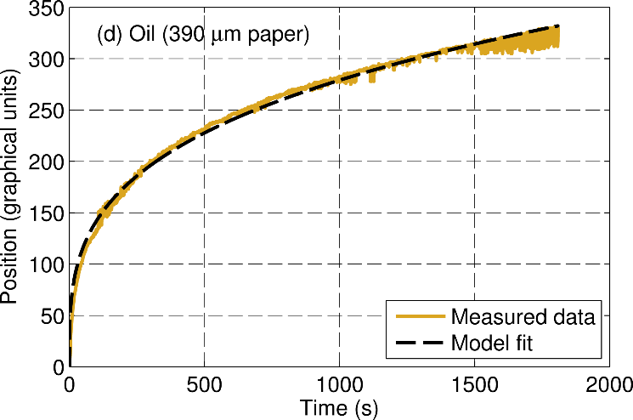

Fig. 6. Measured data and fractional order identification results for video-based diffusion for oil and water for the two types of Whatman paper. Excellent fit to the identified fractional order model is observed.

Table 1: Fractional order identification results for N = 5 replicates

 | α | k
Water (180 μm) | 0.390 ± 0.017 | 33.3 ± 3.4
Oil (180 μm) | 0.406 ± 0.021 | 12.8 ± 2.2
p-value (t-test) | 0.23 | 3.2 × 10⁻⁶
p-value (T²-test) | 2.3 × 10⁻⁷
Water (390 μm) | 0.401 ± 0.012 | 47.2 ± 1.9
Oil (390 μm) | 0.325 ± 0.036 | 27.4 ± 6.7
p-value (t-test) | 1.9 × 10⁻³ | 2.2 × 10⁻⁴
p-value (T²-test) | 2.8 × 10⁻¹¹

Please insert also the following ORCIDs:
Roberto K. H. Galvão - 0000-0001-9794-8815
Mario C. U. Araujo - 0000-0002-7976-3494

